OBSERVATION AND REPORTING

I.Observe the pictures and answer the following :

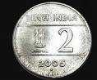

In which country can you use this coin ?
______________________

Which people use this.
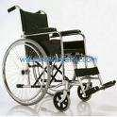
_______________________

The bird makes beautiful nests for its partner.
_____________________
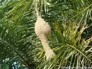

A common desert tree which looks like the coconut
tree .
__________________________

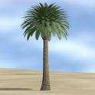

The dress worn by the assame woman:
_______________________

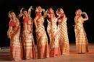

II. Answer the following:
- Why was Shanta not tired ?
___________________________________________________________________________________________________________________________________________________________________________________________________________________________
2.What does Wahida do as a medical officer on the ship ?
_________________________________________________________________________
__________________________________________________________________________________________________________________________________________________

3.How did Pochampalli cloth get its name ?
________________________________________________________________________
________________________________________________________________________

4. Why do people cover their heads in Abu Dhabi ?
___________________________________________________________________________________________________________________________________________________________________________________________________________________________

5. What do you understand by these words:-
a) Prism _____________________________________________________
b) Sand dunes ___________________________________________

iii) Match the following according to the places where the birds make their nest:
- Dove in or around our house
- Indian Robin old building
- Crow courtyard, thorns, mehendi hedge
- Sparrow between the stones
- Pigeon high up on a tree

INDENTIFICATION & CLASSIFICATION

Identify the thing and write its use.
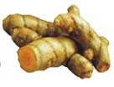
____________________________________________________

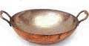
What is the use of this vessel ?
_______________________________________

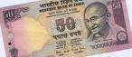 To which country does this belong to ?
____________________________________________________

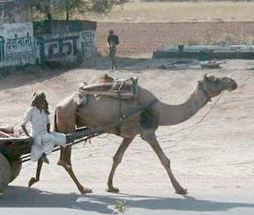
The person who used it
uu uuses it.
___________________________________________

Name the state where this is used uused.
_______________________________________

II. Answer the following :

1. Why should the weeds be removed ?
____________________________________________________________________
____________________________________________________________________
2. Why did Nandita come to Mumbai ?
_________________________________________________________________________
________________________________________________________________________

- What should we do if we have diarrohea and vomiting ?
____________________________________________________________________________________________________________________________________________________________________________________________________________________________________________________________________________________________
- What do you know about –
Bihu _____________________________________________________________
Uruka ___________________________________________________________
- What did Phali, Nazu and her friends do on the beach ?
____________________________________________________________________________________________________________________________________________________________________________________________________________________
- Draw a picture of different food items:

DISCOVERY OF FACTS

- Match the following:
- A person who cannot speak blind
- A person who cannot hear lame
- A person who cannot walk deaf
- A person who cannot see dumb

- Write the few sentences about the desert oak ?
__________________________________________________________________________________________________________________________________________________________________________________________________________________________________________________________________________________________________________________________________________________________________

- Why do birds make nests ?
____________________________________________________________________________________________________________________________________________________________________________________________________________________

- Write any five uses of water ?
___________________________________________________________________________________________________________________________________________________________________________________________________________________________________________________________________________________________________________________________________________________________________

- How do the weavers decide the size of the needles ?
_____________________________________________________________________________________________________________________________________________________________________________________________________________________

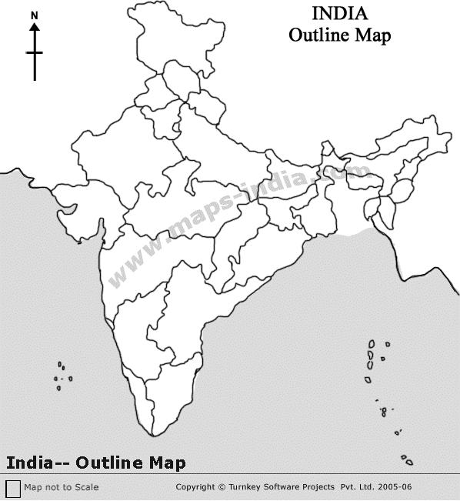
- Identify the following states on the map :

KENDRIYA VIDYALAYA TAMENGLONG
Summative Assessment II (2015-16)

Subject: E V S Time: 02 Hours
Class: V Date:
Name : ................................. Roll no…………

COMPETENCY | OBSERVATION | IDENTIFICATION | DISOVERY OF FACTS | TOTAL
VALUE POINTS
GRADE

Sign of invigilator sign of evaluator.

KENDRIYA VIDYALAYA TAMENGLONG
Summative Assessment II (2015-16)

Subject: E V S Time: 02 Hours
Class: IV Date:
Name : ................................. Roll no…………

COMPETENCY | OBSERVATION | IDENTIFICATION | DISOVERY OF FACTS | TOTAL
VALUE POINTS
GRADE

Sign of invigilator sign of evaluator.

KENDRIYA VIDYALAYA TAMENGLONG
Summative Assessment II (2015-16)

Subject: E V S Time: 02 Hours
Class: III Date:
Name : ................................. Roll no…………

COMPETENCY | OBSERVATION | IDENTIFICATION | DISOVERY OF FACTS | TOTAL
VALUE POINTS
GRADE

Sign of invigilator sign of evaluator.

